Thank you to the 800+ customers who entered Connect and Win 5.
Please see below the winning entries, and congratulations to our three winners who’ll be receiving a $500 gift card each!
- XXX
- XXX
- XXX
There was a clear winner in terms of what feature you would like to see implemented on the platform:
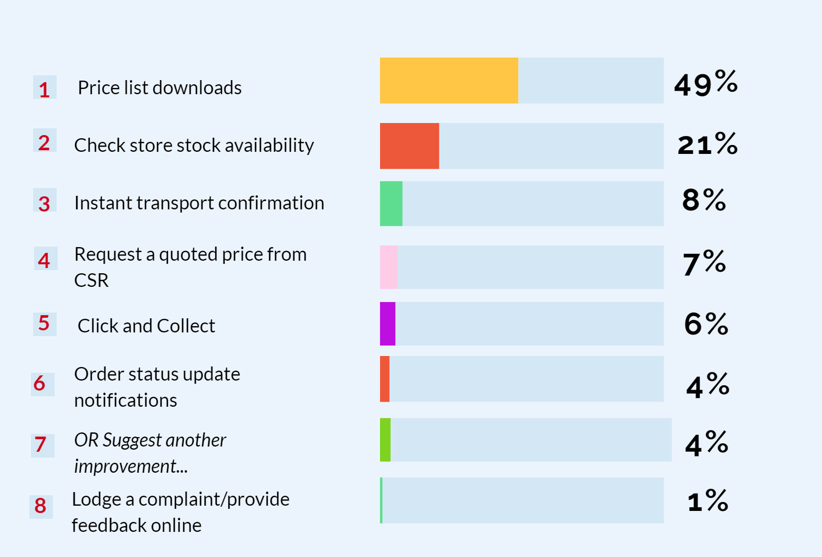
We also had some amazing suggestions for new improvements. Here’s a few of our favourites:
- If a product is not in stock, list dates when stock will be back in for despatch, with a confirmation update to our email for re-ordering and planning jobs
- Would be a great addition if CSR could connect to accounting software
- Being able to secure outbound delivery slots via Connect. Being able to see in real time what delivery windows are still available on a certain day
We’ll be starting to implement these features very soon, so login to CSR Connect and keep an eye out.

